**DAILY ONLINE ACTIVITIES SUMMARY**

|  |  |  |  |  |  |  |  |  |
| --- | --- | --- | --- | --- | --- | --- | --- | --- |
| **Date:** | **02-6-2020** | | | | | **Name:** | **Likhitha.M** | |
| **Sem & Sec** | **6th sem ‘A’** | | | | | **USN:** | **4al17cs046** | |
| **Online Test Summary** | | | | | | | | |
| **Subject** | | **Computer graphics and Visualization** | | | | | | |
| **Max. Marks** | | **30** | | **Score** | | | **30** | |
| **Certification Course Summary** | | | | | | | | |
| **Course** | **Cloud Foundations** | | | | | | | |
| **Certificate Provider** | | | **Great learning** | | **Duration** | | | **3 days** |
| **Coding Challenges** | | | | | | | | |
| **Problem Statement:**   1. Python program to return a list containing first and last element using list slicing method   2.Write a program to check if given linked list has a loop or not  3.Given an array of positive integers. Write a C Program to find inversion count of array.**Inversion Count:** For an array, inversion count indicates how far (or close) the array is from being sorted. If array is already sorted then inversion count is 0. If array is sorted in reverse order that inversion count is the maximum.  Formally, two elements a[i] and a[j] form an inversion if a[i] > a[j] and i < j. Input: The first line of input contains an integer T denoting the number of test cases. The first line of each test case is N, the size of array. The second line of each test case contains N elements. **Output:**  Print the inversion count of array. Constraints: 1 ≤ T ≤ 100  1 ≤ N ≤ 107  1 ≤ C ≤ 1018 | | | | | | | | |
| **Status: completed** | | | | | | | | |
| **Uploaded the report in Github** | | | | | **yes** | | | |
| **If yes Repository name** | | | | | **https://github.com/likhithaMantaral/Daily-status** | | | |
| **Uploaded the report in slack** | | | | | **yes** | | | |

Online test Details:

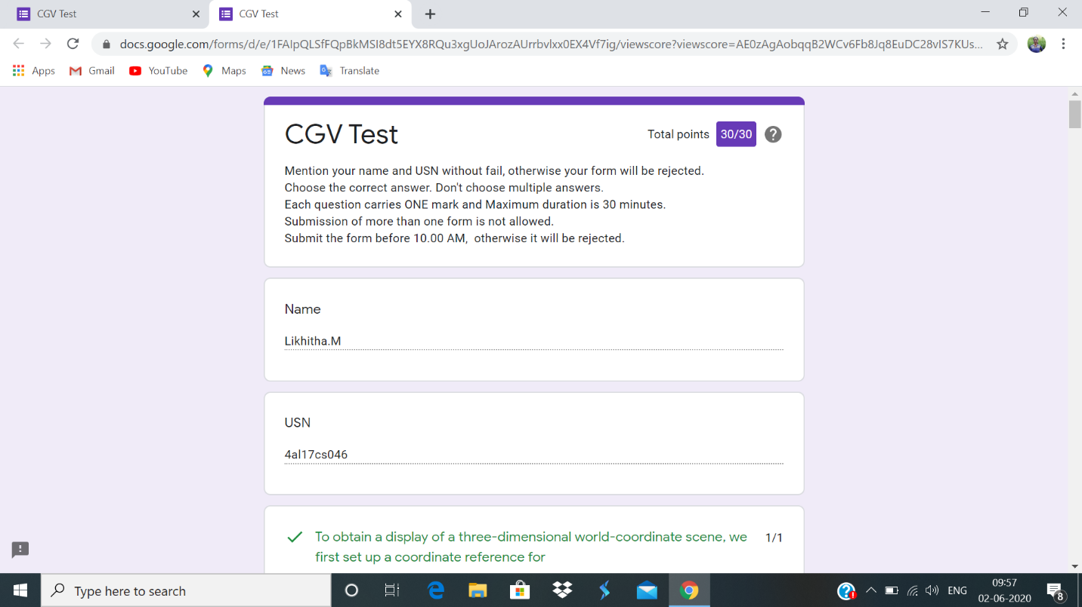

Certification Course Details:

**Price Economics, Data Velocity and Distributed Computing**

Cloud allows you to control and monitor the ops cost. The price is arrived at – cost based pricing, value based pricing. The cost is based on- Building the product, maintaining the product, supporting the product etc. Values are based on-Longevity of the product, customer perception about the product. Challenges with Distributed computing are- Heterogeneity, Fault handling, consistency etc.

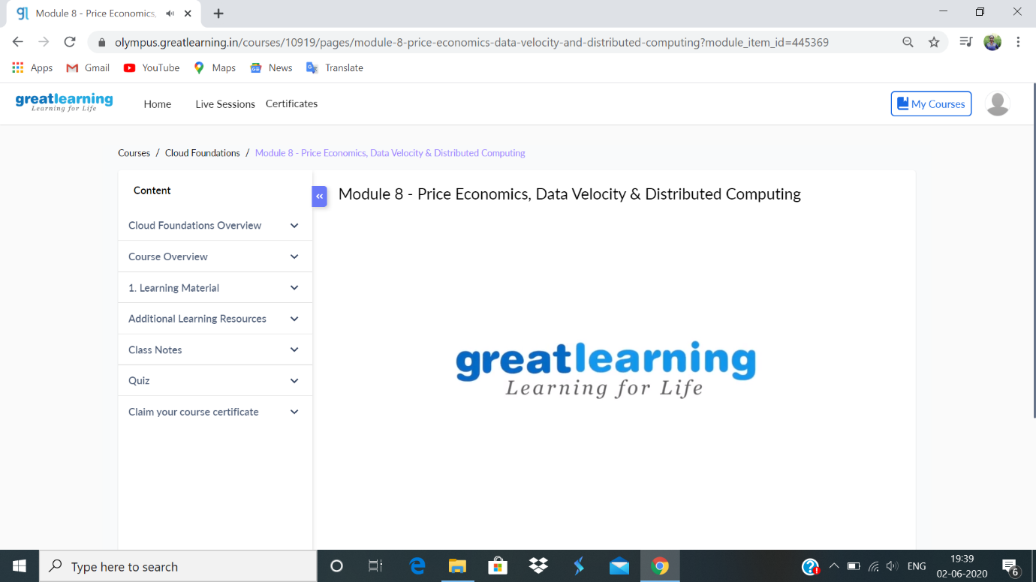



**Coding challenge:**

**1.**

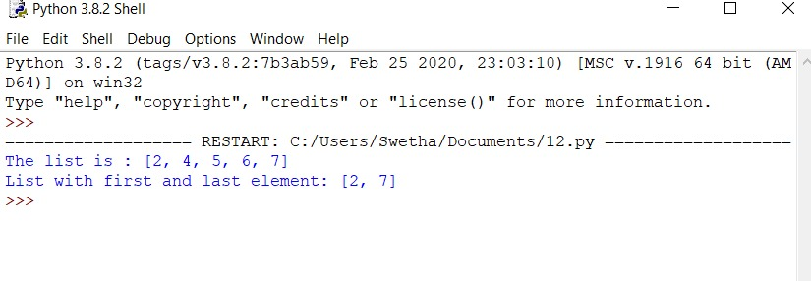

**2.**

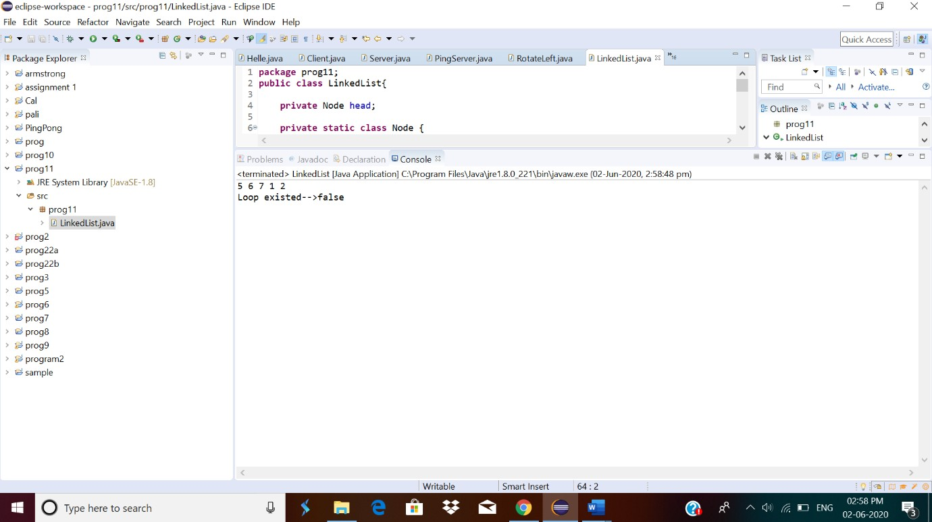

3.

